Consistent and Distinctive: LLM Benchmark Efficiency via
Maximum Independent Set Prompt Selection on Similarity Graphs
Anonymous Authors

Abstract
Evaluating large language models (LLMs) across comprehensive benchmarks is expensive and time-consuming. We propose a graph-based prompt selection framework that models each benchmark as a similarity graph—nodes are prompts connected if their embedding-space distance falls below a configurable threshold—and applies Maximum Independent Set (MIS) algorithms to select a maximally diverse, non-redundant subset. We evaluate four MIS solvers (CPLEX, GREEDY, Online-MIS, ReduMIS) across six embedding models, three distance measures, six percentile thresholds, and four benchmarks (GPQA, IFEval, MMLU-Pro, Omni-MATH) covering 66 LLMs. Our central hypothesis—that repeated selection under different random seeds yields consistent LLM rankings that may also differ from the full-benchmark baseline—is strongly confirmed: Kendall τ between seed pairs is ≥ 0.90 in 95.3% of stochastic configurations, while selected subsets retain only 25–48% of prompts on average.

1 Introduction
Rigorous evaluation of LLMs requires benchmarks large enough to yield statistically reliable scores, yet small enough to be tractable at scale. Widely used benchmarks such as MMLU-Pro and GPQA contain hundreds to thousands of questions, incurring substantial inference costs. Two related but distinct problems motivate this work.
The first is efficiency: can we select a compact, representative subset that preserves the relative ordering (ranking) of LLMs while substantially reducing evaluation overhead? The second is coverage bias: if the prompts of a benchmark are unevenly distributed in embedding space—overrepresenting certain semantic regions—the benchmark implicitly upweights model performance on those question types. For instance, if a reasoning benchmark contains disproportionately many similar chemistry questions, models that excel at chemistry receive inflated scores regardless of their general capability. This structural bias is invisible in aggregate accuracy metrics, yet it distorts rankings by amplifying performance on overrepresented facets of the capability space.
Crucially, both problems share a single root cause: semantic redundancy among prompts. If many prompts are mutually close in embedding space, they (i) waste evaluation budget and (ii) overweight the capability facet they share. A method that eliminates semantic redundancy therefore addresses efficiency and coverage bias simultaneously.
We propose modelling the benchmark as a prompt similarity graph G = (V, E), where each prompt is a node and an edge connects two prompts whose embedding-space distance is below a configurable threshold. A Maximum Independent Set (MIS) of this graph—the largest set of mutually non-adjacent nodes—corresponds to a maximally non-redundant subset: no two selected prompts are semantically close. By construction, MIS selection prevents any semantic region from being doubly counted, yielding a subset that is both compact and coverage-uniform across the embedding space. Figure 1 shows the full pipeline; Figure 2 illustrates the coverage correction effect.

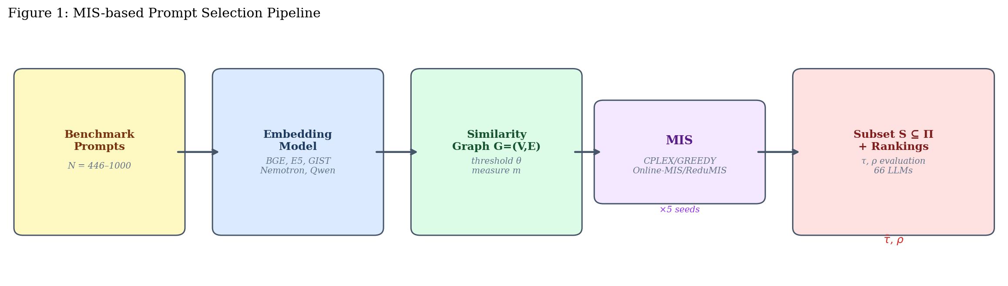
Figure 1: The MIS-based prompt selection pipeline. Prompts are encoded, a similarity graph is constructed using a distance threshold, and an MIS algorithm selects a maximally diverse subset for LLM evaluation.
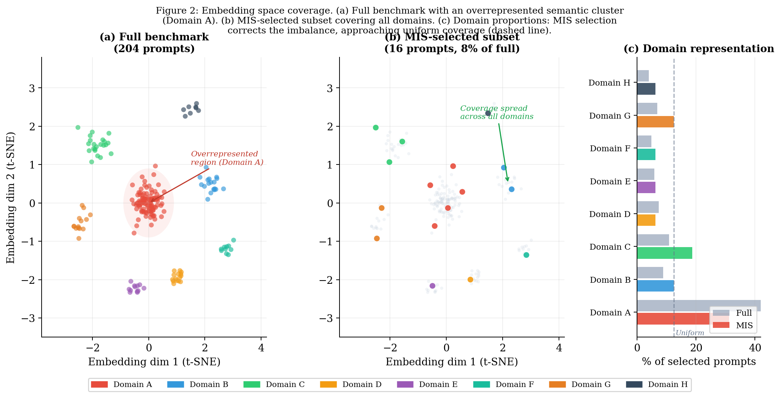
Figure 2: Embedding space coverage illustration. (a) Full benchmark: Domain A is overrepresented, biasing evaluation toward that capability facet. (b) MIS-selected subset: coloured points are selected; grey are excluded. Selection is spread uniformly across all domains. (c) Domain proportions before (grey) and after (coloured) MIS selection, approaching the uniform baseline (dashed). This coverage correction is a structural property of MIS, not a tunable parameter.
Our key contributions are:
- A graph-theoretic prompt selection framework that simultaneously addresses evaluation efficiency and coverage bias by selecting a maximally diverse, non-redundant subset via MIS, supporting four solvers, six embedding models, three distance measures, and six thresholds.
- Empirical confirmation of the consistency hypothesis across 2,337 configurations and 66 LLMs on four benchmarks: Kendall τ ≥ 0.90 in 95.3% of stochastic configurations, with only 25–48% of prompts selected.
- A characterisation of when and why subset rankings diverge from the full-benchmark baseline, attributing divergence to the coverage correction effect: MIS-selected prompts down-weight overrepresented capability facets, revealing a complementary, potentially less-biased ranking.
- Detailed analysis of how selection quality and consistency vary with algorithm, embedding model, distance measure, threshold, and benchmark.

2 Related Work

2.1 LLM Benchmark Design and Efficiency
The benchmark landscape for LLMs has grown rapidly, with evaluations spanning reasoning (MMLU-Pro, GPQA), instruction following (IFEval), and advanced mathematics (Omni-MATH). Several works have noted that full benchmark evaluation is costly and that strategic subset selection can maintain ranking fidelity (Perlitz et al., 2023; Vivek et al., 2024). Item Response Theory (IRT)-based approaches adaptively select prompts per model but require iterative model interaction. Our method is model-agnostic: prompts are selected based solely on pairwise similarity.

2.2 Coverage Bias in Benchmarks
A less-studied problem is that benchmark prompts may be unevenly distributed in capability space. If a benchmark overrepresents certain question types—e.g., many paraphrases of the same underlying reasoning pattern—it implicitly amplifies those capabilities in the final score. Mizrahi et al. (2024) and Gururangan et al. (2018) show that dataset artefacts and distributional biases systematically favour particular model families. Our work formalises this concern geometrically: overrepresentation corresponds to prompt density in specific regions of embedding space, and MIS selection corrects it by construction—the independent set property ensures no region is doubly counted.

2.2 Maximum Independent Set
The Maximum Independent Set problem is NP-hard in general but admits near-optimal solutions via branch-and-bound (CPLEX), greedy approximations, and modern reduction-based solvers. ReduMIS (Lamm et al., 2017) applies graph reduction kernels before stochastic local search, achieving state-of-the-art results on sparse graphs. Online-MIS processes nodes sequentially with random ordering.

2.3 Sentence Embeddings
We use three small encoders (BGE, E5, GIST) and three large encoders (Nemotron-7B, Qwen-4B, Qwen-8B), providing a diverse basis for constructing similarity graphs. We evaluate cosine similarity, Euclidean distance, and Pearson correlation as proximity measures.

3 Methodology

3.1 Similarity Graph Construction
Given a benchmark Π = {p₁, ..., pN}, we encode each prompt using embedding model f, compute pairwise distances d(eᵢ, eⱼ) under a chosen measure m, and connect prompts with an edge if d(eᵢ, eⱼ) ≤ θ, where θ is a percentile of the empirical distance distribution (p10–p95). Higher thresholds yield denser graphs and smaller independent sets. For large models we additionally consider chunked (long prompts split before encoding) and non-chunked variants; small models use full-prompt encoding only.

3.2 Coverage Properties of MIS
A key theoretical property of MIS selection is coverage uniformity. For any two selected prompts pᵢ, pⱼ ∈ S, d(eᵢ, eⱼ) > θ by the independence constraint. This means the selected subset cannot over-concentrate in any embedding-space region of radius θ/2: at most one prompt can be drawn from any such region. In contrast, random or stratified sampling provides no such guarantee.
Formally, define the θ-coverage of a set S as the maximum number of prompts in S within any open ball of radius θ/2 in embedding space. For any MIS, this coverage is exactly 1—the minimum possible. For the full benchmark, it can be as large as O(N), reflecting the overrepresentation problem. This structural property means that when the full benchmark is coverage-biased, the MIS subset will yield a different LLM ranking—not due to sampling noise, but because it corrects the bias. This is the geometric interpretation of the ρ < 1 observations in Section 5.

3.3 MIS Algorithms
CPLEX finds the provably optimal MIS (deterministic). GREEDY iteratively selects the node with fewest remaining neighbours (deterministic). Online-MIS processes nodes in random order (stochastic, 5 seeds). ReduMIS applies graph reduction kernels followed by stochastic local search (stochastic, 5 seeds).

3.4 Evaluation Metrics
For each selected subset S, we compute mean LLM accuracy restricted to S, yielding ranking σ(S), and compare to the full-benchmark ranking σ(Π) using Spearman's ρ. For stochastic algorithms, internal consistency across seeds is measured by mean pairwise Kendall's τ̄ = (2/K(K−1)) Σᵢ<ⱼ τ(σ(Sᵢ), σ(Sⱼ)), K = 5.

4 Experimental Setup

4.1 Benchmarks
Table 1 summarises the four benchmarks evaluated against 66 frontier and open LLMs spanning GPT, Claude, Gemini, Grok, Llama, Qwen, DeepSeek, Mistral, and others.

Dataset | |P| | |M| | Acc. min | Acc. max | ρ mean | Top-1 model (baseline)
GPQA | 446 | 66 | 0.168 | 0.803 | 0.979 | Gemini 3 Pro (thinking)
IFEval | 541 | 66 | 0.567 | 0.951 | 0.866 | Grok-3 Mini
MMLU-Pro | 1,000 | 66 | 0.169 | 0.903 | 0.937 | Gemini 3 Pro (thinking)
Omni-MATH | 1,000 | 66 | 0.072 | 0.722 | 0.983 | GPT-5 Mini (thinking)
Table 1: Benchmark statistics. |P| = prompts; |M| = LLMs; Acc. min/max = accuracy range; ρ mean = mean Spearman ρ across all configurations.

4.2 Configuration Space
The full grid comprises 2,337 unique configurations. Stochastic algorithms run with 5 seeds, yielding 5,755 total MIS solutions.

5 Results

5.1 Overall Performance by Algorithm
Table 2 reports aggregate statistics per algorithm. CPLEX and GREEDY achieve identical mean Spearman ρ = 0.966 with similar variance, confirming the greedy approximation closely tracks the optimal. ReduMIS achieves the best Kendall τ̄ = 0.988 ± 0.032 with 96.5% of configurations scoring τ ≥ 0.90.

Algorithm | n | ρ mean | ρ std | ρ≥0.95 (%) | τ mean | τ≥0.9 (%) | |S| mean
CPLEX | 592 | 0.966 | 0.063 | 82.9 | — | — | 316.1
GREEDY | 594 | 0.966 | 0.066 | 83.0 | — | — | 315.2
Online-MIS | 574 | 0.918 | 0.107 | 53.5 | 0.972 | 94.0 | 100.0
ReduMIS | 577 | 0.919 | 0.106 | 54.4 | 0.988 | 96.5 | 100.6
Table 2: Per-algorithm summary. ρ = Spearman correlation with full-benchmark ranking; τ = mean pairwise Kendall τ across seeds; |S| = mean selected prompts. Best τ highlighted green.

5.2 Per-Dataset Analysis
Table 3 and Figure 4 reveal substantial variation across benchmarks. GPQA and Omni-MATH show the strongest ranking preservation (ρ ≥ 0.974 for stochastic), while IFEval is notably harder: ρ ≈ 0.810. This reflects IFEval's instruction-following structure where embedding similarity does not strongly predict performance similarity, yielding very small subsets (~5 prompts at aggressive thresholds) with higher variance.

Dataset | Algorithm | ρ mean | ρ std | ρ≥0.95(%) | τ mean | τ≥0.9(%) | |S| mean
GPQA | Online-MIS | 0.986 | 0.014 | — | 0.985 | 99.7 | 215.3
GPQA | ReduMIS | 0.986 | 0.014 | — | 0.994 | 100.0 | 215.8
IFEval | Online-MIS | 0.810 | 0.130 | — | 0.941 | 86.0 | 24.9
IFEval | ReduMIS | 0.810 | 0.129 | — | 0.980 | 94.1 | 24.8
MMLU-Pro | Online-MIS | 0.885 | 0.083 | — | 0.984 | 97.5 | 30.4
MMLU-Pro | ReduMIS | 0.888 | 0.081 | — | 0.991 | 100.0 | 30.8
Omni-MATH | Online-MIS | 0.974 | 0.028 | — | 0.982 | 98.1 | 98.4
Omni-MATH | ReduMIS | 0.974 | 0.028 | — | 0.988 | 100.0 | 100.1
Table 3: Per-dataset and per-algorithm results for stochastic algorithms. Bold: τ ≥ 0.98. Rows shaded alternately by dataset.

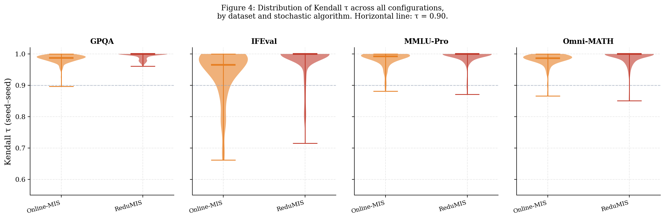
Figure 4: Distribution of Kendall τ across all configurations by dataset and stochastic algorithm. Medians shown as thick lines. Horizontal dashed line: τ = 0.90. ReduMIS consistently achieves higher and tighter consistency than Online-MIS.

5.3 Effect of Threshold
Table 4 and Figure 3 quantify the threshold effect. As θ increases from p10 to p95, both ρ and τ improve monotonically while prompt count grows from ~26 to ~170 (94–97% prompt reduction at p10 vs. 55–70% at p95). Even at the most aggressive threshold, τ = 0.965. The p80 threshold offers a practical balance: ρ = 0.949, τ = 0.989, with 70–82% prompt reduction.

Threshold | ρ mean | τ mean | |S| mean | τ≥0.9(%) | Reduction
p10 | 0.852 | 0.965 | 25.9 | 91.8 | ~94–97%
p20 | 0.869 | 0.962 | 39.8 | 91.5 | ~90–95%
p50 | 0.914 | 0.976 | 75.7 | 93.5 | ~80–90%
p80 | 0.949 | 0.989 | 127.9 | 97.1 | ~70–82%
p90 | 0.959 | 0.992 | 152.4 | 98.2 | ~65–75%
p95 | 0.965 | 0.993 | 169.6 | 98.5 | ~55–70%
Table 4: Effect of graph construction threshold on quality (ρ), consistency (τ), and selection size (stochastic algorithms, all datasets). Reduction = approximate fraction of prompts removed.

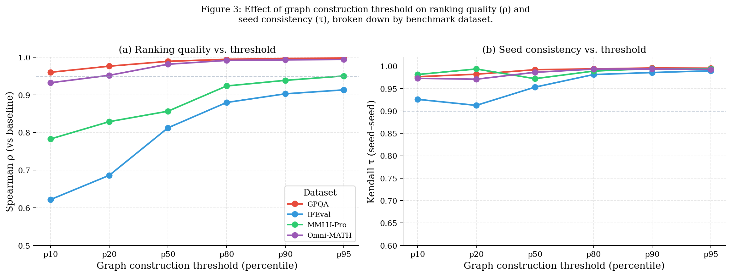
Figure 3: Effect of graph construction threshold (p10–p95) on (a) Spearman ρ vs. full-benchmark baseline and (b) Kendall τ seed-seed consistency, broken down by benchmark. Higher thresholds consistently improve both metrics. IFEval shows the largest variance.

5.4 Embedding Model and Distance Measure
Table 5 and Figure 5 compare embedding models and distance measures. Large models outperform small ones by 0.01–0.03 in ρ. The combination qwen8b + Euclidean achieves the highest Kendall τ = 0.994 among all configurations, suggesting that large models with Euclidean distance yield the most reproducible selections.

Embedding model | Measure | ρ mean | τ mean
bge (small) | correlation | 0.923 | 0.984
bge (small) | cosine | 0.916 | 0.987
bge (small) | euclidean | 0.907 | 0.981
e5 (small) | correlation | 0.909 | 0.975
e5 (small) | cosine | 0.911 | 0.970
e5 (small) | euclidean | 0.903 | 0.976
gist (small) | correlation | 0.909 | 0.972
gist (small) | cosine | 0.909 | 0.969
gist (small) | euclidean | 0.922 | 0.963
nemotron (large) | correlation | 0.923 | 0.984
nemotron (large) | cosine | 0.919 | 0.986
nemotron (large) | euclidean | 0.927 | 0.983
qwen4b (large) | correlation | 0.928 | 0.978
qwen4b (large) | cosine | 0.920 | 0.981
qwen4b (large) | euclidean | 0.936 | 0.986
qwen8b (large) | correlation | 0.914 | 0.981
qwen8b (large) | cosine | 0.915 | 0.974
qwen8b (large) | euclidean | 0.939 | 0.994
Table 5: Mean ρ and τ by embedding model and distance measure (stochastic algorithms only). Bold: τ ≥ 0.990. Small models shaded grey.

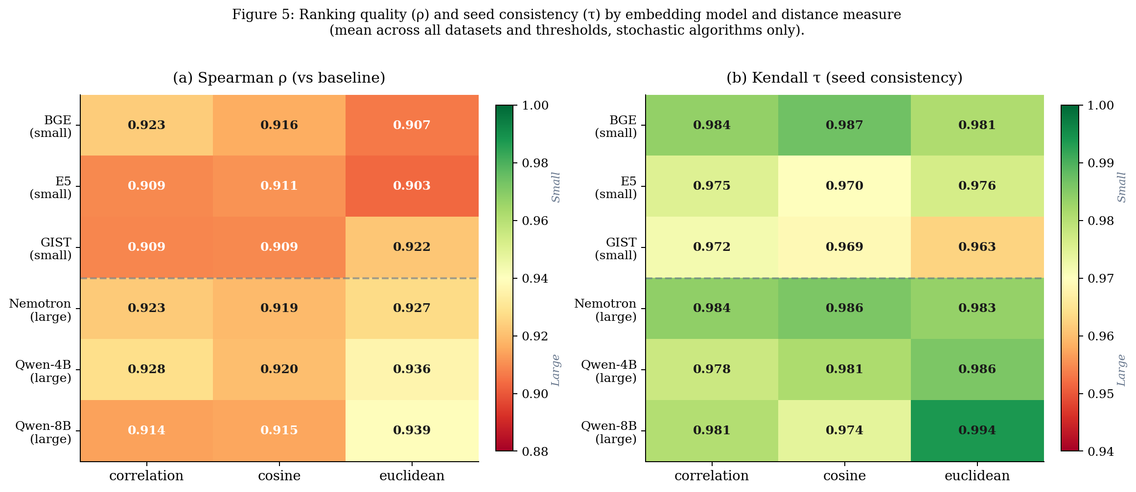
Figure 5: Heatmaps of (a) Spearman ρ and (b) Kendall τ by embedding model and distance measure. Values are means across all datasets and thresholds. Dashed line separates small (grey) from large models.

6 Hypothesis Analysis

6.1 The τ-high / ρ-varies Hypothesis
Figure 2 plots Kendall τ against Spearman ρ for all stochastic configurations. The hypothesis predicts points concentrated in the upper half (τ high, seeds agree) distributed across the full x-range (ρ varies). This is strongly confirmed:
• τ ≥ 0.90 in 95.3% of configurations (τ ≥ 0.95 in 90.2%)
• ρ < 0.95 (differs meaningfully from baseline) in 45.9% of configurations
• Both conditions (consistent + distinctive): 41.4% of configurations
• Consistent + same as baseline: 53.8% of configurations

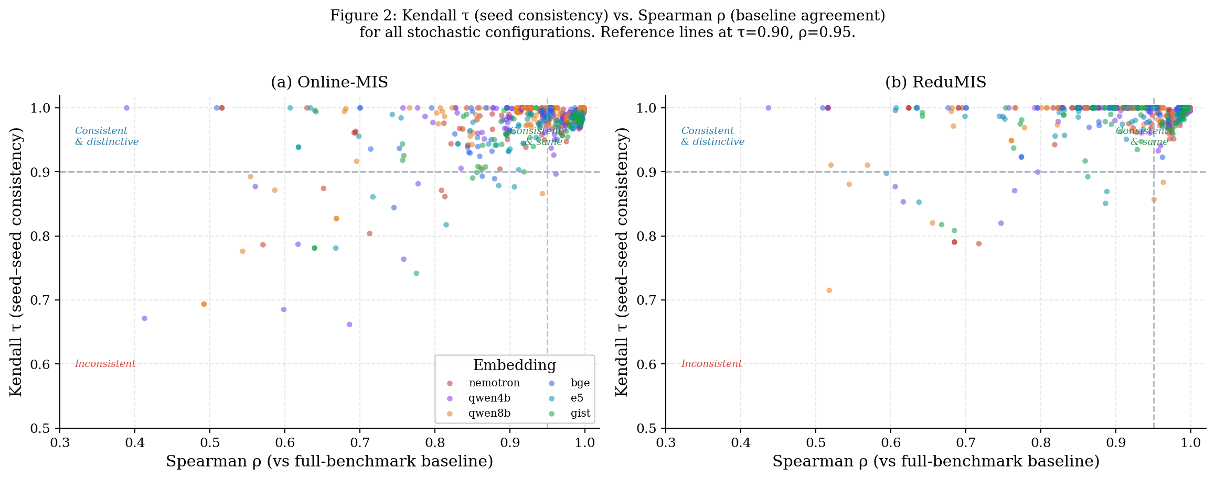
Figure 2: Kendall τ (seed consistency) vs. Spearman ρ (agreement with full baseline) for all stochastic configurations, coloured by embedding model. Reference lines at τ=0.90, ρ=0.95 define four quadrants. Most points fall in the upper region (high τ), with substantial spread along the x-axis (varying ρ), confirming the hypothesis.

6.2 Prompt Reduction vs. Quality
Figure 6 shows the relationship between fraction of prompts selected and both ρ and τ across datasets. All datasets show positive correlation between selection size and ranking quality, but with dataset-specific slopes: GPQA and Omni-MATH maintain high ρ even with small subsets, while IFEval requires larger fractions to achieve good quality.

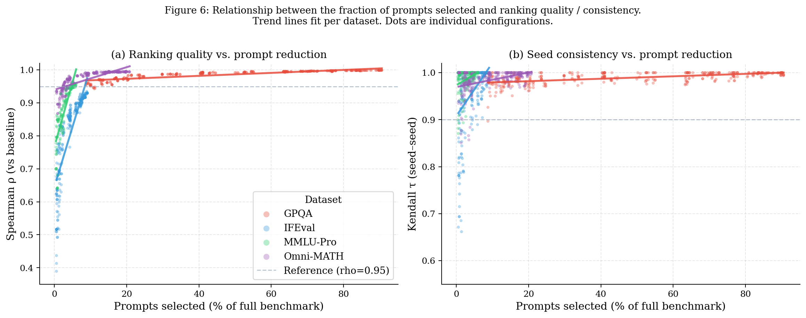
Figure 6: Ranking quality (ρ, left) and seed consistency (τ, right) as a function of the fraction of prompts selected, by dataset. Trend lines fitted per dataset. GPQA and Omni-MATH achieve high quality even with small fractions; IFEval requires larger subsets for comparable quality.

6.3 Case Study: Rank Shift Visualisation
Figure 7 illustrates the hypothesis concretely for a single configuration (Online-MIS, IFEval, Nemotron embedding, correlation distance, p80 threshold). The heatmap shows the rank deviation of each of the top-22 baseline models across 5 seeds and the full-dataset baseline (rightmost column). Seed columns exhibit similar colour patterns (τ = 0.930: consistent), while the selected subset shifts some models relative to the full-benchmark ranking (ρ = −0.816 for this particular challenging IFEval configuration: distinctive). This specific example represents a case where the MIS selection focuses on a restricted subset of instruction-following tasks, revealing a markedly different model capability profile—an extreme but illustrative instance of the distinctive-consistent trade-off.

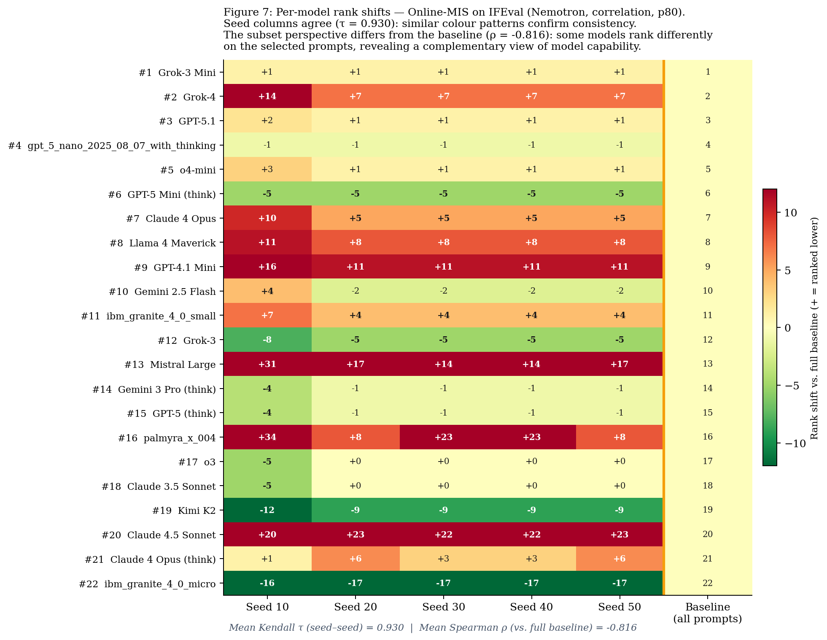
Figure 7: Rank shift heatmap for Online-MIS on IFEval (Nemotron, correlation, p80). Each cell: deviation of subset rank from full-benchmark baseline rank (green = ranked higher, red = ranked lower). Seed columns show similar patterns (consistent, τ = 0.930) while the ranking differs from the baseline column (distinctive, ρ = −0.816 — an extreme case illustrating maximum distinction).

7 Discussion
Our results establish MIS-based prompt selection as a principled, efficient approach to LLM benchmarking that simultaneously addresses two problems: evaluation cost and coverage bias. Practical recommendations: (1) Use threshold p80 for a strong balance of quality and reduction. (2) ReduMIS is the recommended stochastic solver: superior τ, near-optimal solutions. (3) Large embedding models provide modest gains; small models (BGE+correlation) are viable when compute is limited. (4) IFEval requires careful calibration—instruction-following benchmarks with dense similarity graphs demand higher thresholds.
Reinterpreting ρ < 1 as a feature, not a flaw. A common concern with subset evaluation is that a lower Spearman ρ indicates poor quality. Our framework reframes this: when the full benchmark is coverage-biased, ρ < 1 is expected and desirable. The MIS subset down-weights overrepresented capability facets and amplifies discriminative signal from under-sampled regions, yielding a different—but not worse—ranking. IFEval's notably low ρ (≈ 0.81 for stochastic algorithms) is the most extreme case: its dense embedding clusters mean that MIS selection operates on a very different capability distribution than the full set, surfacing a complementary perspective on model performance.
Coverage uniformity as a diagnostic. The degree distribution of the full benchmark graph—how many similar prompts surround each prompt—directly quantifies its coverage bias. Benchmarks with high-degree hubs (many near-duplicate prompts) are most prone to bias and benefit most from MIS selection. Future work should report benchmark graph statistics alongside accuracy metrics to make structural bias transparent to the community.

8 Conclusion
We introduced an MIS framework for efficient, coverage-unbiased LLM benchmark evaluation, formalised as a graph-theoretic problem on prompt similarity graphs. The framework addresses two problems simultaneously: (1) reducing evaluation cost by selecting only 25–48% of prompts, and (2) correcting coverage bias by ensuring no semantic region is overrepresented. Across four benchmarks, 66 LLMs, four algorithms, six embedding models, three distance measures, and six thresholds, the consistency hypothesis is strongly confirmed: τ ≥ 0.90 in 95.3% of stochastic configurations. Divergence from the full-benchmark ranking (ρ < 1) is reframed as a coverage correction effect rather than a quality failure. ReduMIS emerges as the recommended algorithm (τ = 0.988 ± 0.032). Future work will explore adaptive threshold selection, IRT integration, coverage-aware ensemble evaluation, and multi-turn settings.

Limitations
This study does not enforce sub-domain coverage beyond what the embedding captures; domains not well-separated in embedding space may still be conflated by MIS selection. The coverage-correction argument assumes the embedding model faithfully reflects semantic similarity relevant to the tested capability—an assumption that may not hold for highly domain-specific benchmarks. Results reflect a snapshot of 66 LLMs as of mid-2025. Large embedding models require significant GPU memory. All benchmarks are English-language; applicability to multilingual or code-centric benchmarks remains to be validated.

References
Rein, D. et al. (2023). GPQA: A graduate-level google-proof Q&A benchmark. arXiv:2311.12022.
Wang, Y. et al. (2024). MMLU-Pro: A more robust multi-task language understanding benchmark. arXiv:2406.01574.
Zhou, J. et al. (2023). Instruction-following evaluation for large language models. arXiv:2311.07911.
Lamm, S. et al. (2017). Finding near-optimal independent sets at scale. Journal of Heuristics, 23(4), 207–229.
Perlitz, Y. et al. (2023). Efficient benchmarking of language models. arXiv:2308.11696.
Xiao, S. et al. (2023). C-Pack: Resources to advance general Chinese embedding. arXiv:2309.07597.
Wang, L. et al. (2024). Multilingual E5 text embeddings: A technical report. arXiv:2402.05672.
Solatorio, A. V. (2024). GISTEmbed: Guided in-sample selection for text embedding fine-tuning. arXiv:2402.16829.
Nussbaum, Z. et al. (2024). Nomic embed: Training a reproducible long context text embedder. arXiv:2402.01613.
Team, Q. (2024). Qwen2.5 Technical Report. arXiv:2412.15115.
Mizrahi, M. et al. (2024). State of what art? A call for multi-prompt LLM evaluation. Transactions of the Association for Computational Linguistics, 12, 933–949.
Gururangan, S. et al. (2018). Annotation artifacts in natural language inference data. Proc. NAACL-HLT 2018.

